3 Android Security Architecture

4 Android App Development Cycle

5 Android Application Components

6 Setting up Android Testing Lab

7 Android Debug Bridge

8 Android Startup Process

9 Unzipping Android Application

10 Reversing Android Application

11 Application signing and Building

12 Analyzing Dex Files

13 Owasp Mobile Top 10

14 Android Traffic Analysis & Interception

15 Damn Insecure & Vulnerable App

16 Insecure Logging

17 Hardcoding Issues

18 Insecure Data Storage

19 Database Insecure Storage

20 Temporary Files Insecure Storage

21 External Insecure Data Storage

22 SQL Injection in Android

23 Abusing Web View in Android

24 Access Control Issues

25 Authentication Based Access Control Issues

26 Leaking Content Provider

27 Hardcoding Issues Using JNI

28 DOS Attack in Android

29 Insecure Bank

30 API Hooking

31 JDB Java Debugger

32 Drozer Security Framework

1 Android Penetration Testing Overview

2. Android Architecture

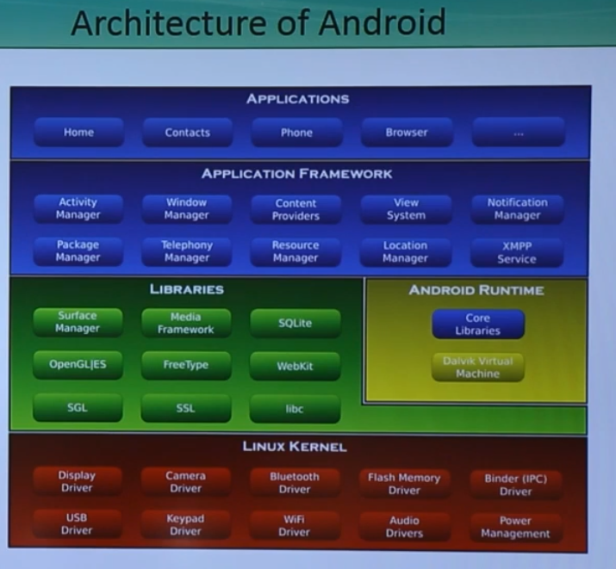

3 Android Security Architecture

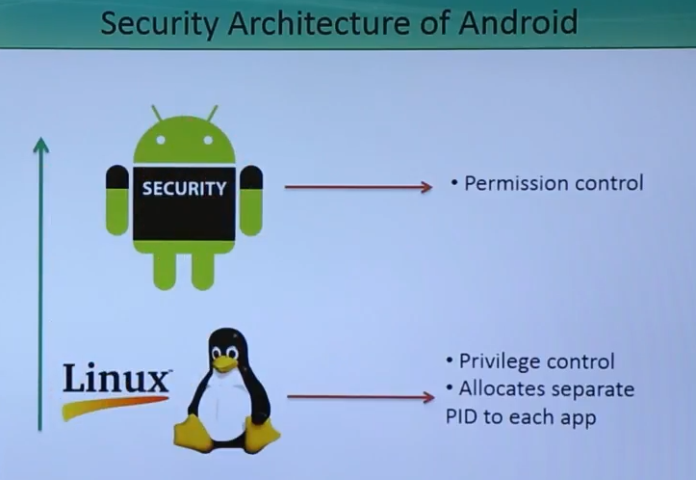

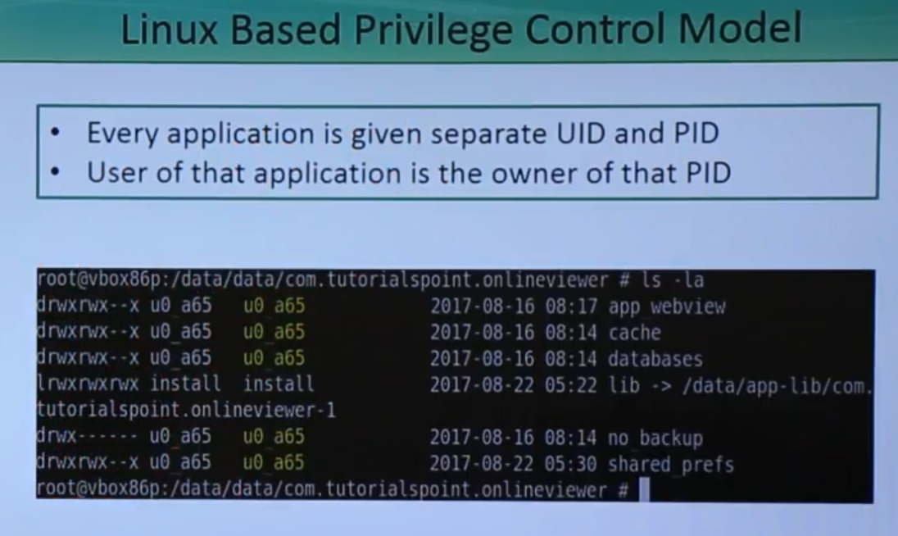

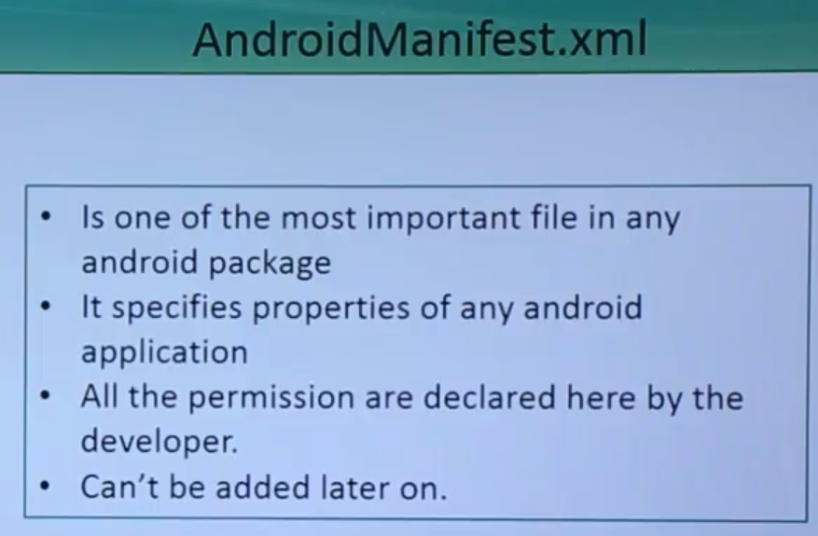

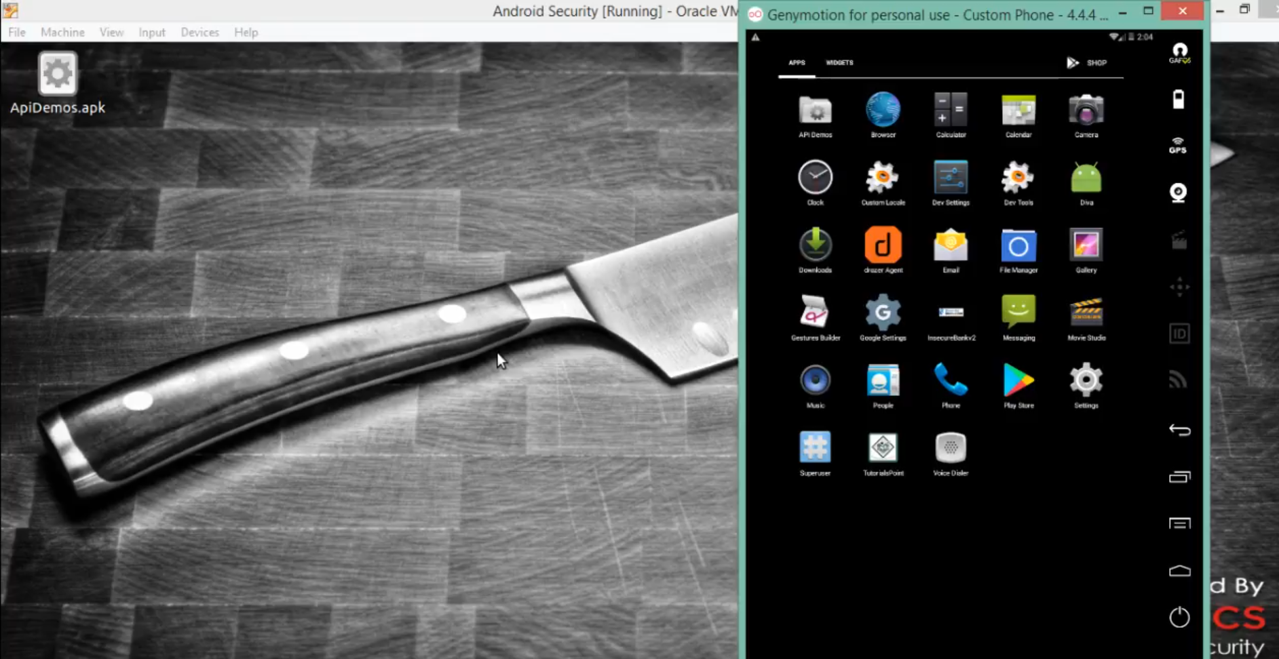

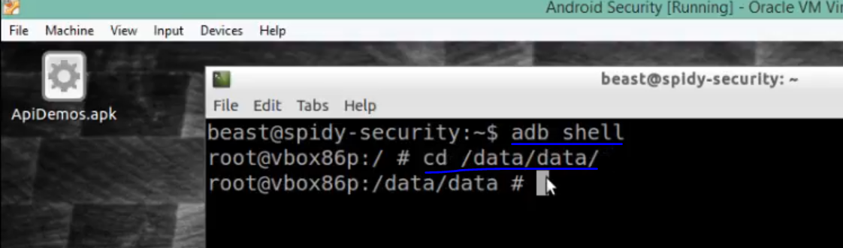

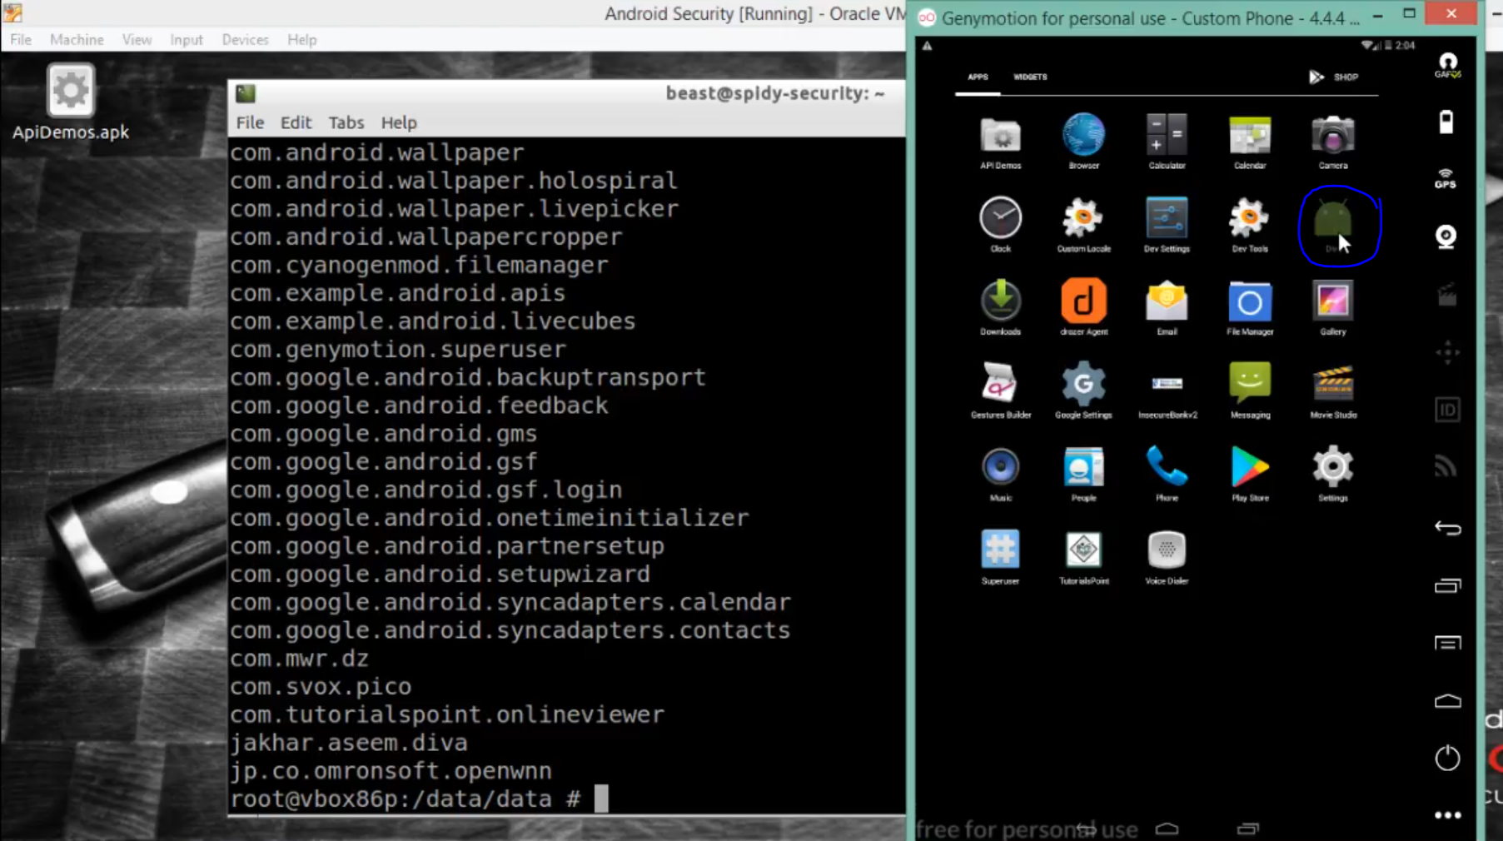

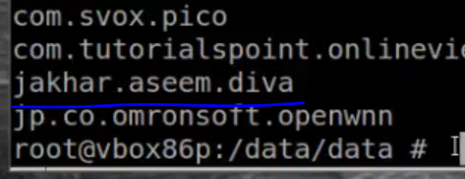

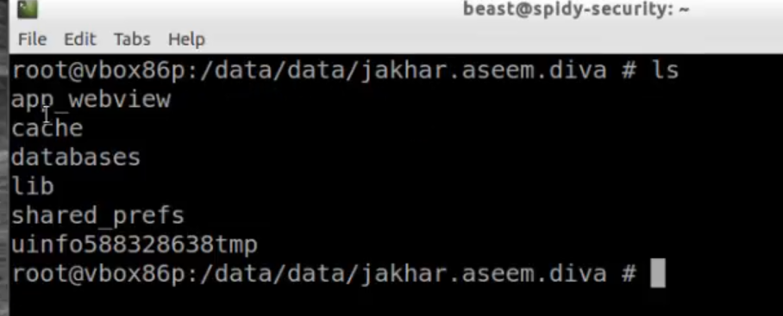

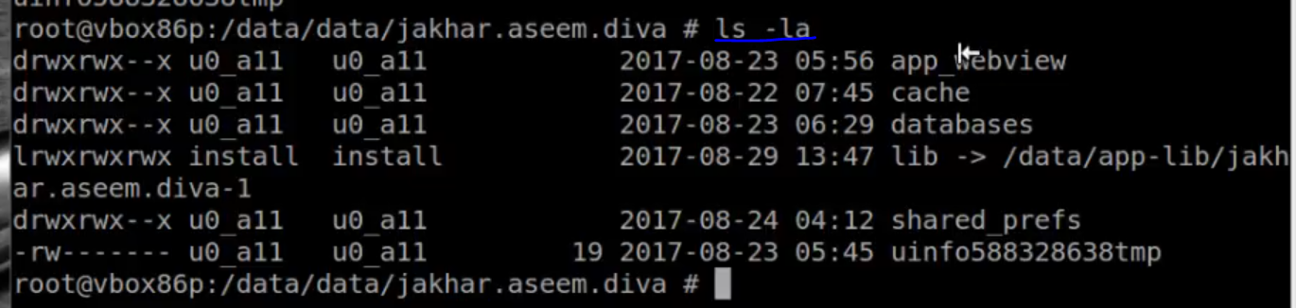

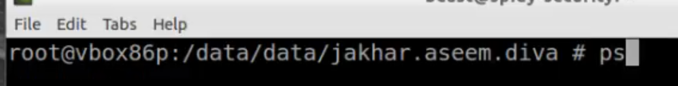

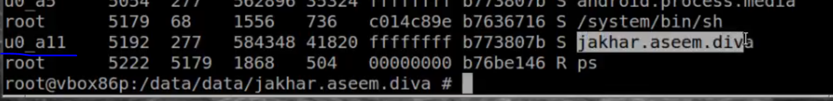

Decompiled an android package, viewed android permissions inside manifesto.ini

4. Android App Development Cycle

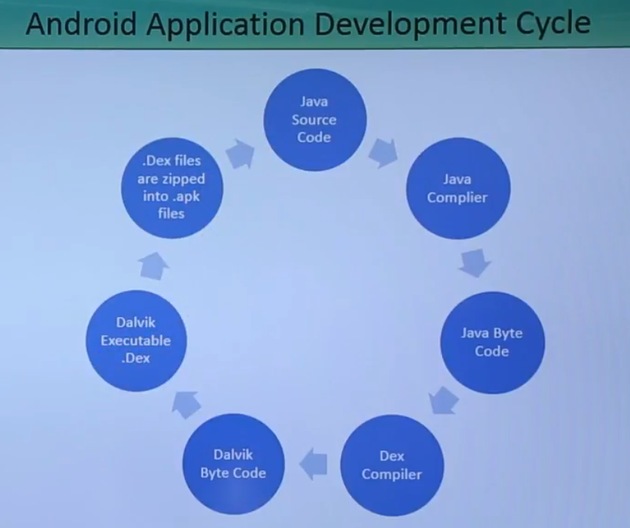

5 Android Application Components

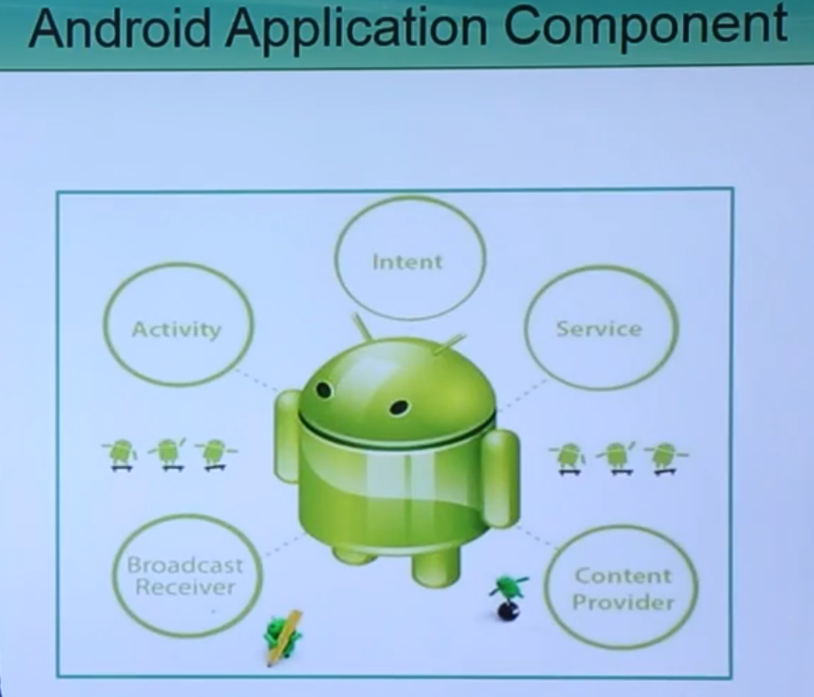

6 Setting up Android Testing Lab

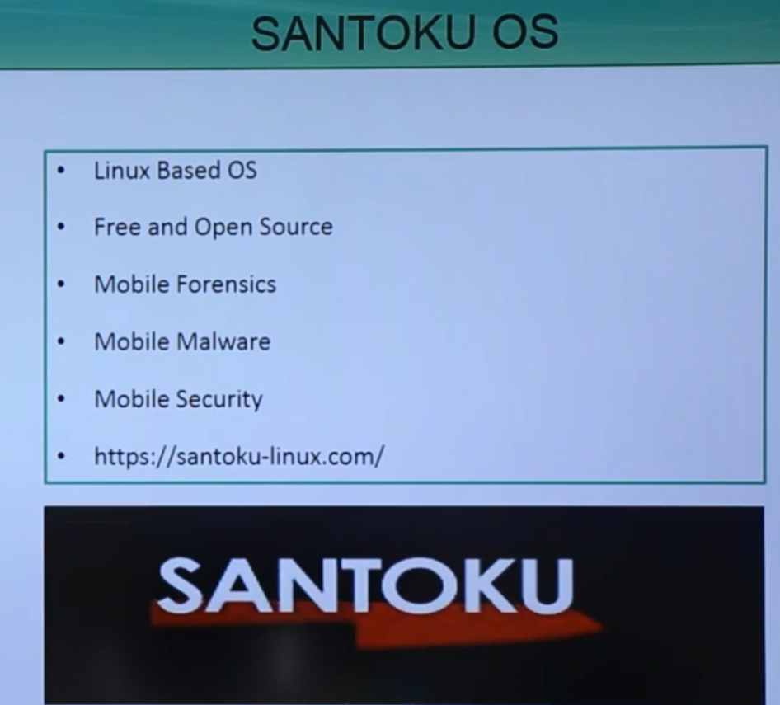

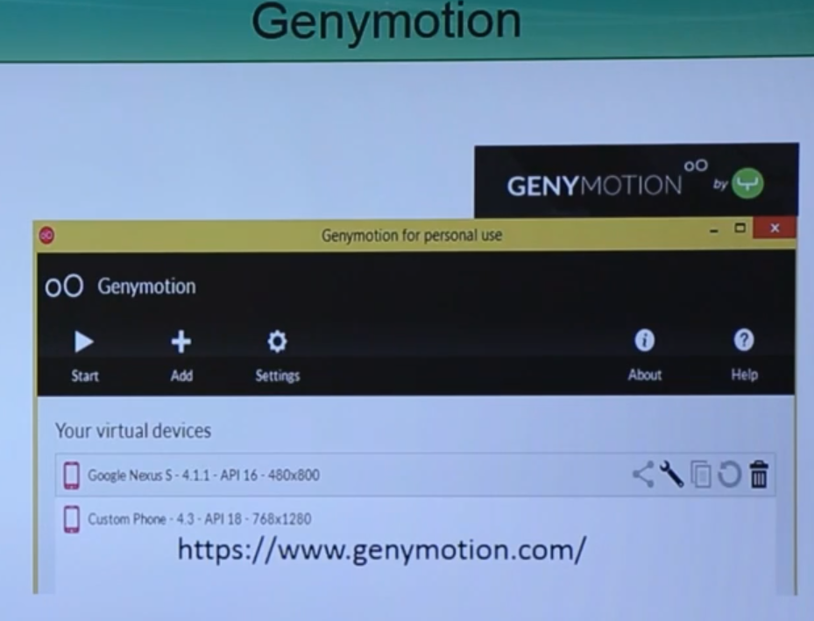

7 Android Debug Bridge

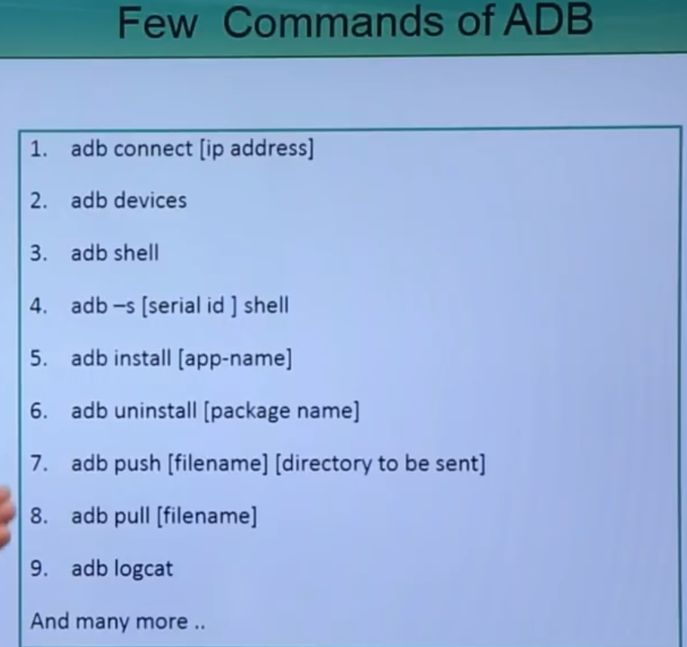

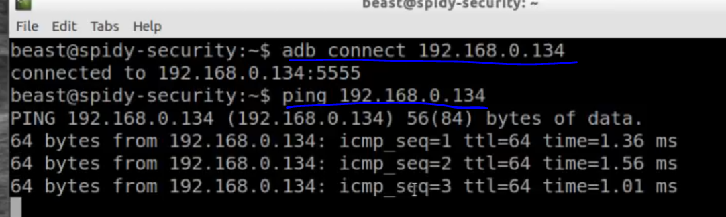

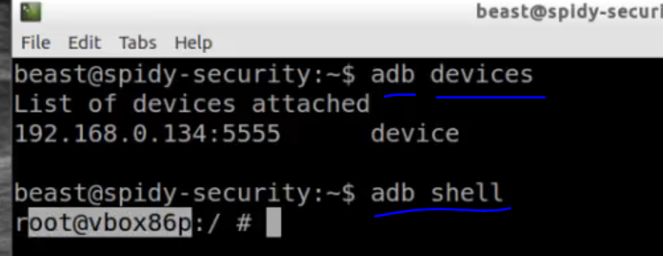

Ls

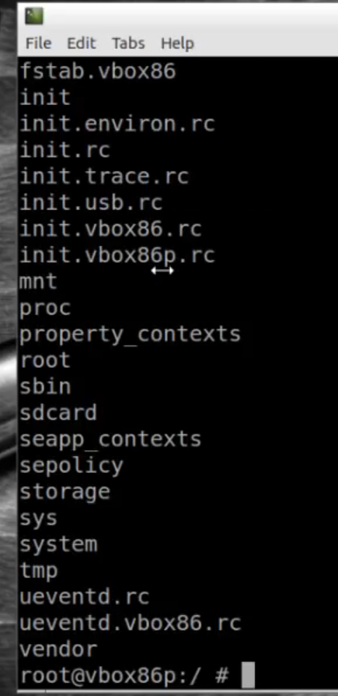

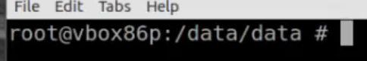

Ls

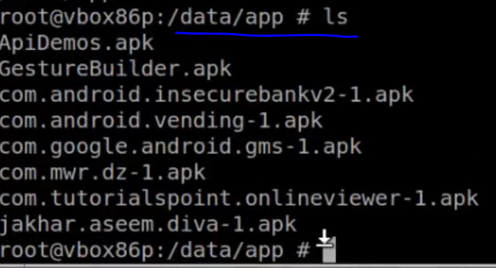

External storae

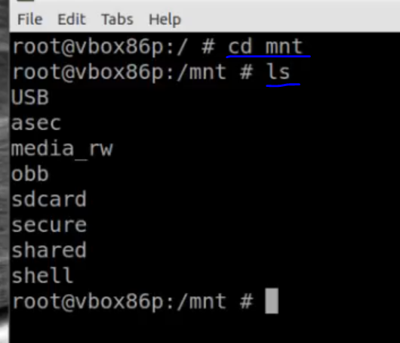

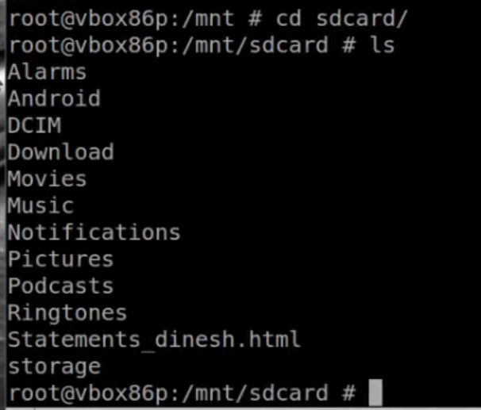

Installing App



To uninstall

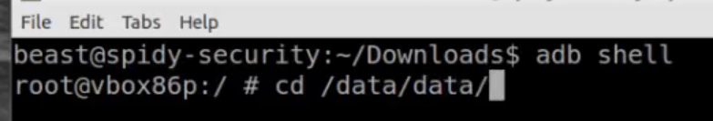

Hit ener

Ls

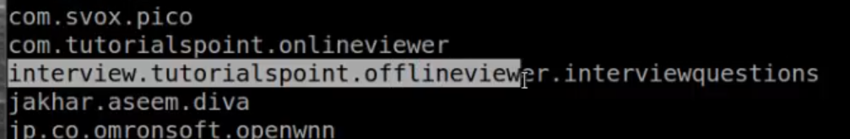

Adb uninstall package name



To executecommands, go to adb shell

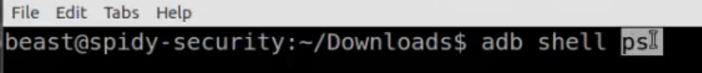

To view o file

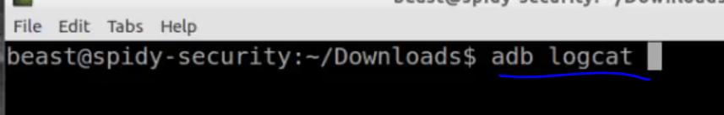

To pul app to Desktop

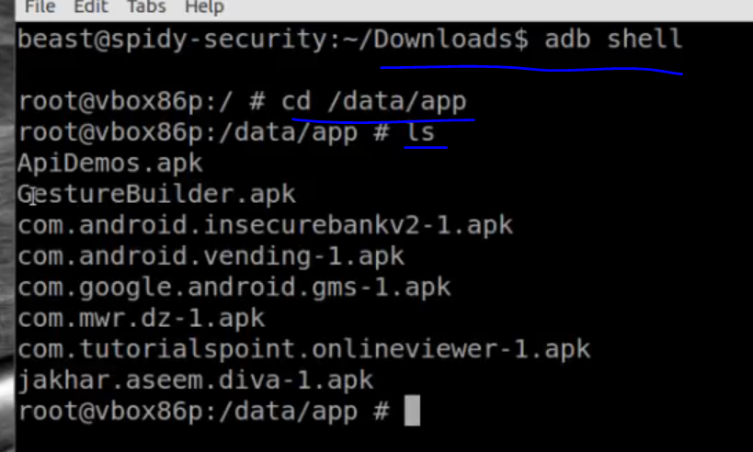

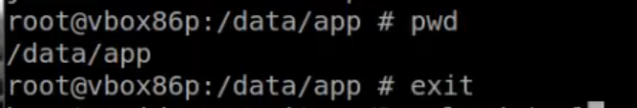

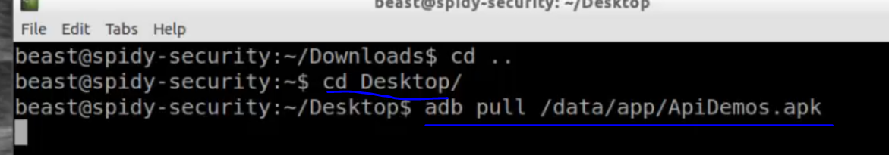

8 Android Startup Process

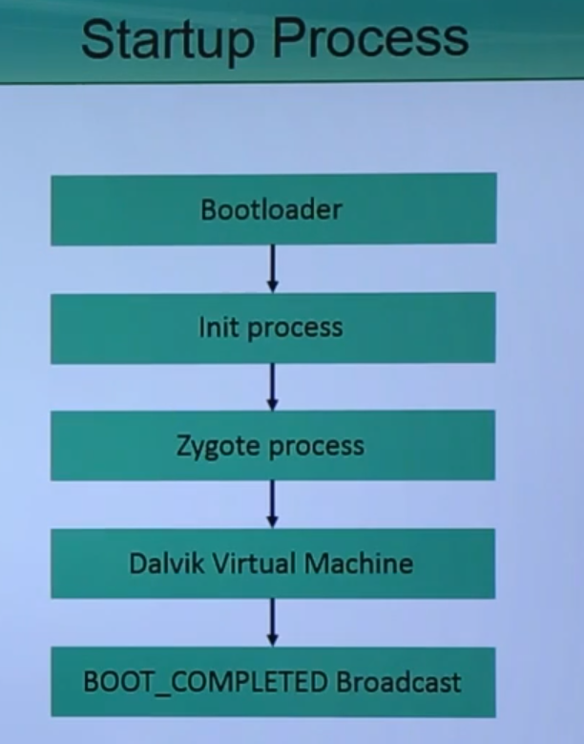

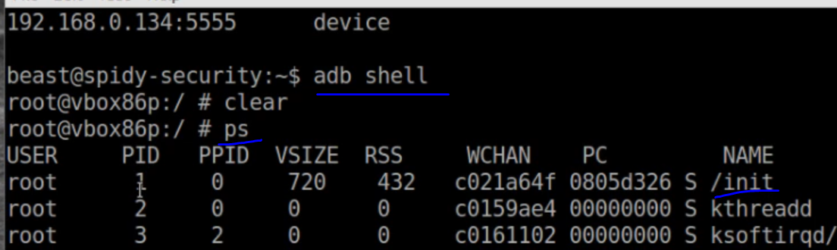

From root folder

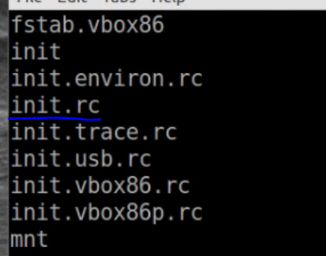

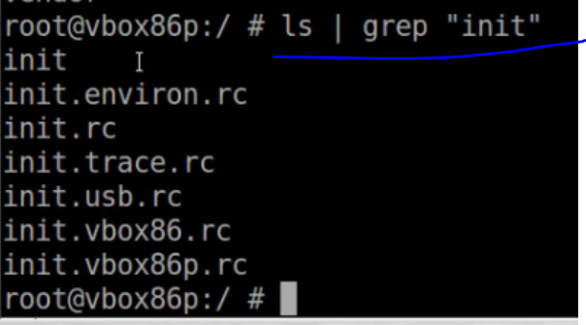

Cat init.rc

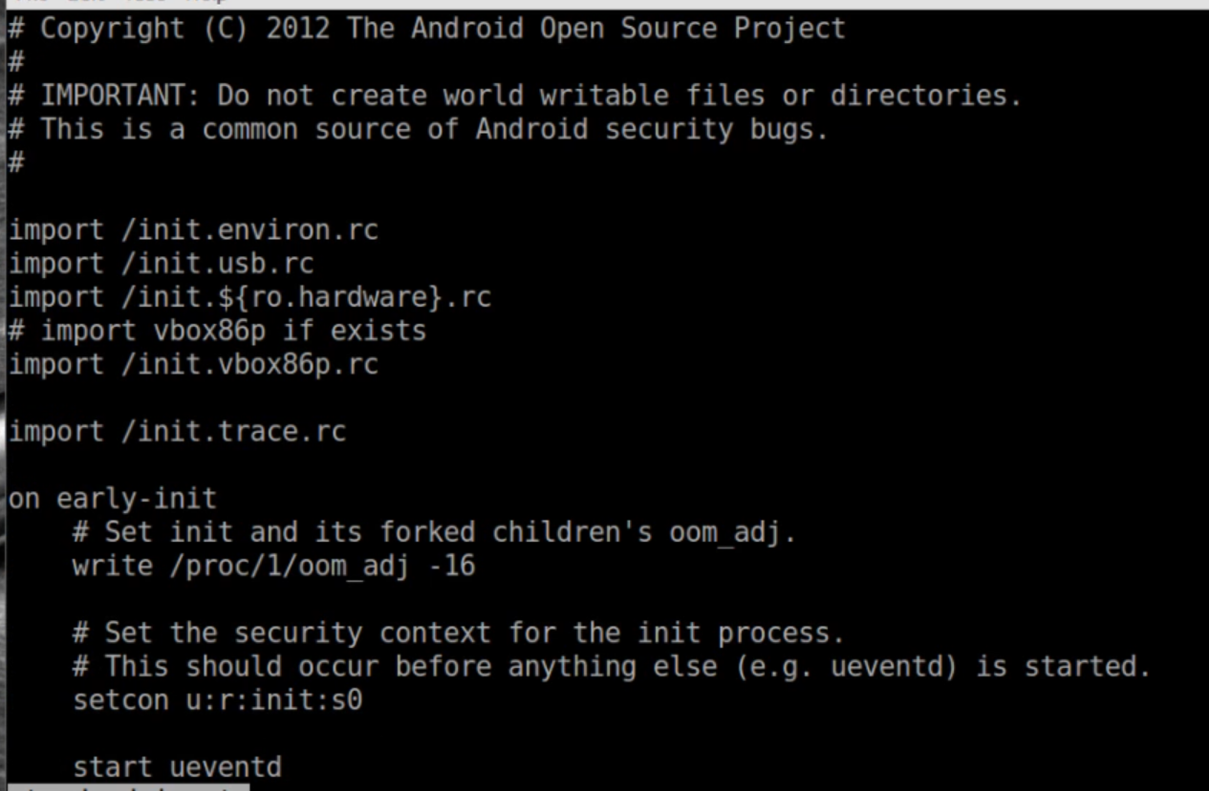

Responsible for mounting various file system & loading kernel components

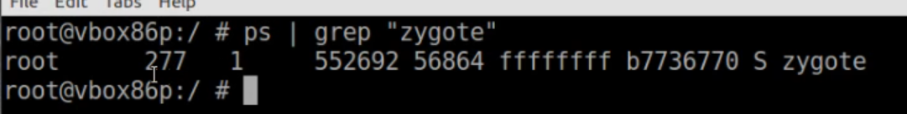

9 Unzipping Android Application

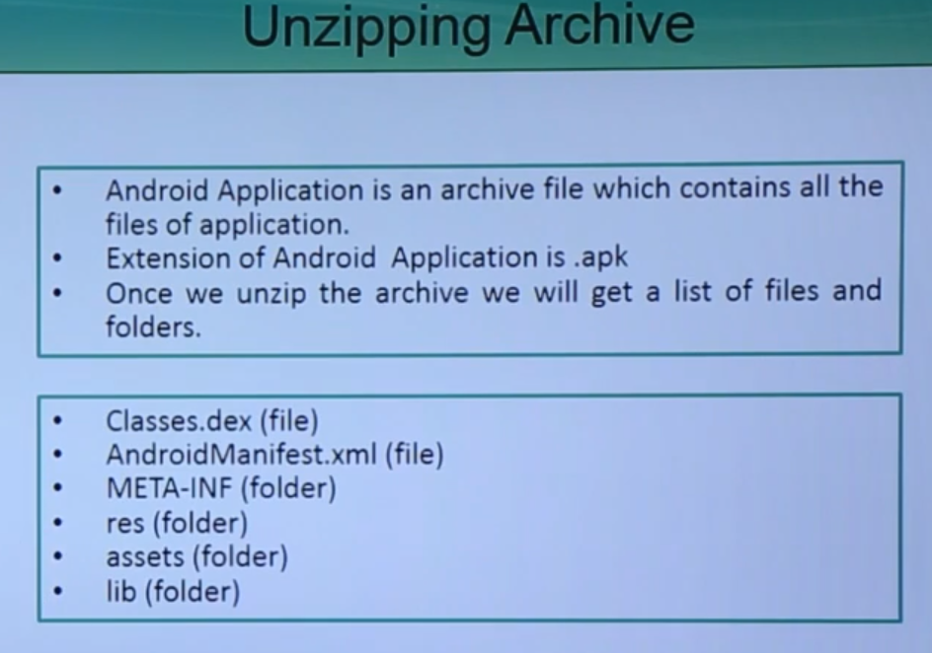

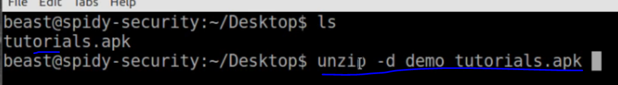

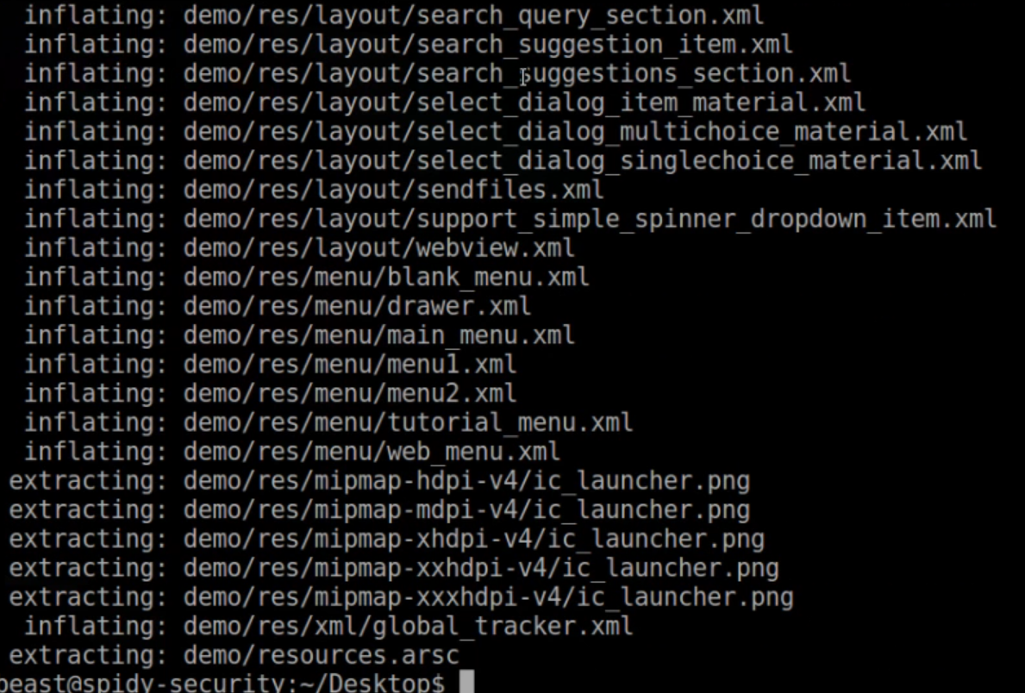

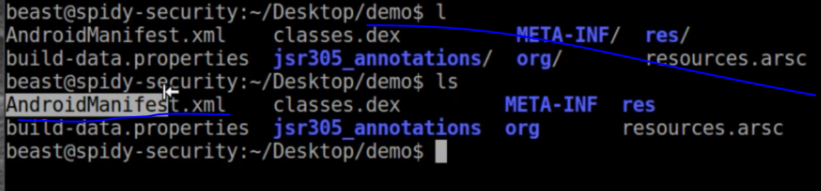

10 Reversing Android Application

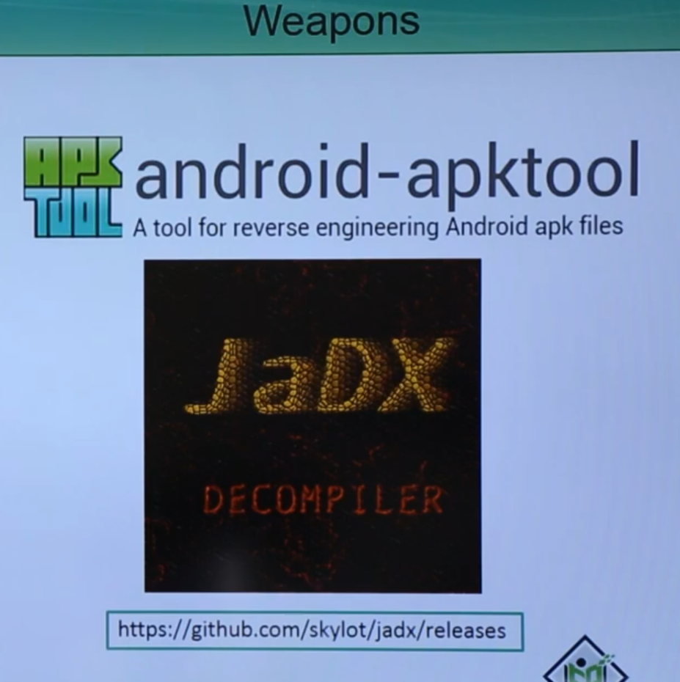

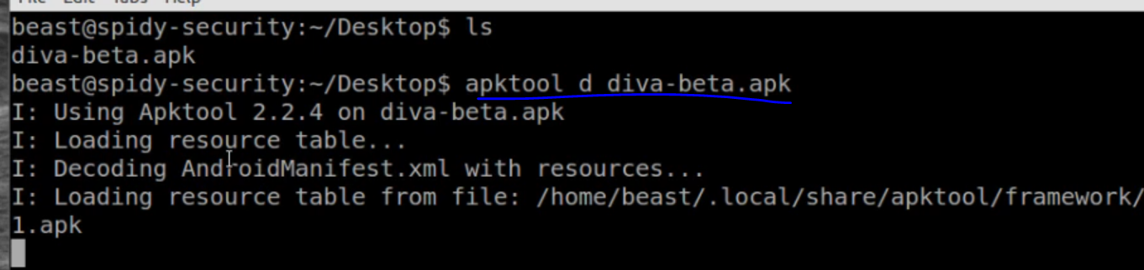

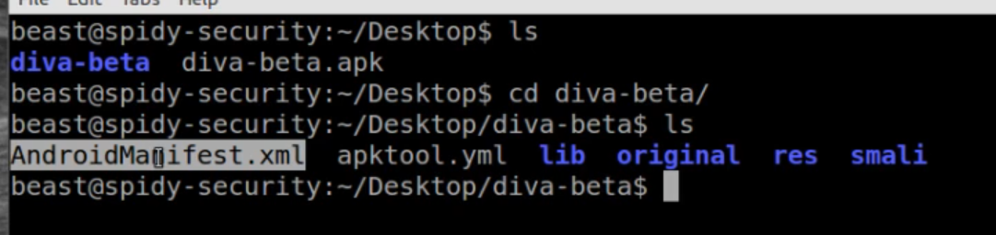

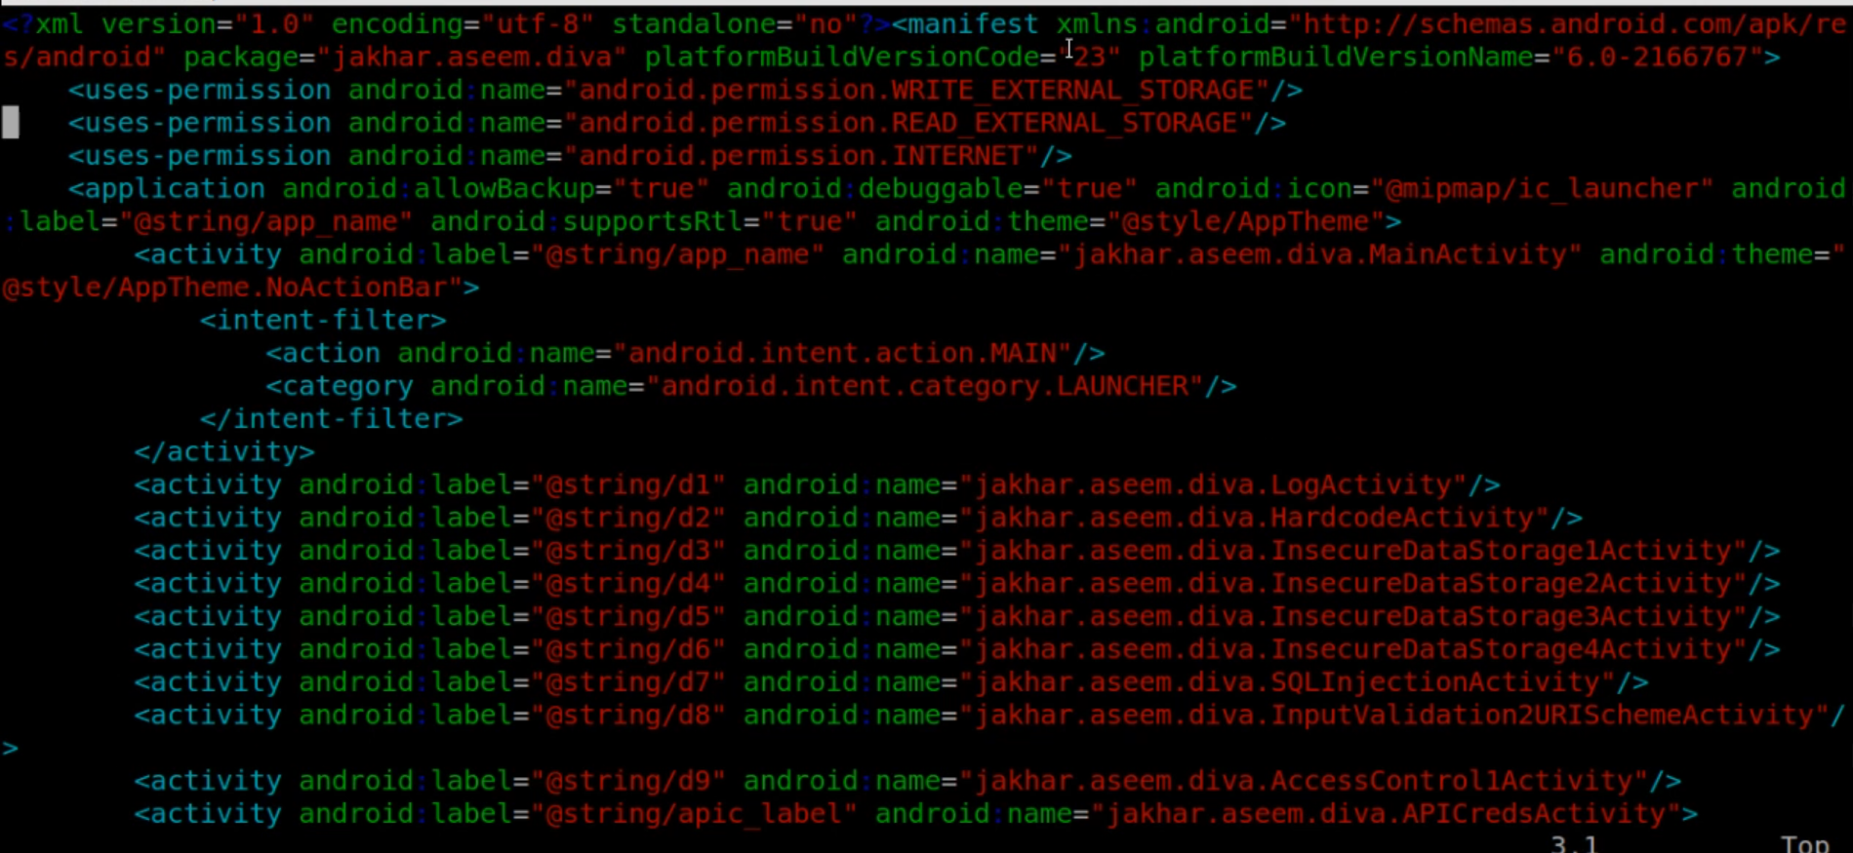

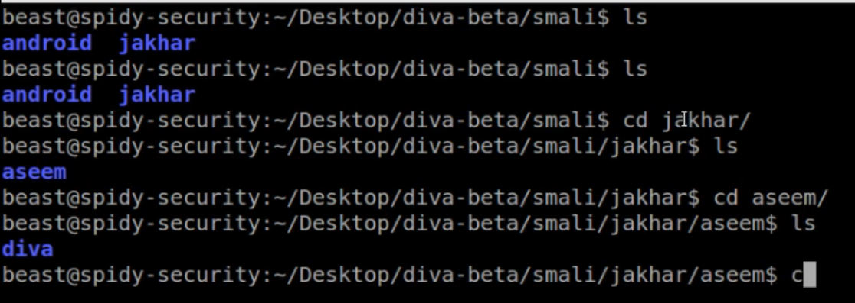

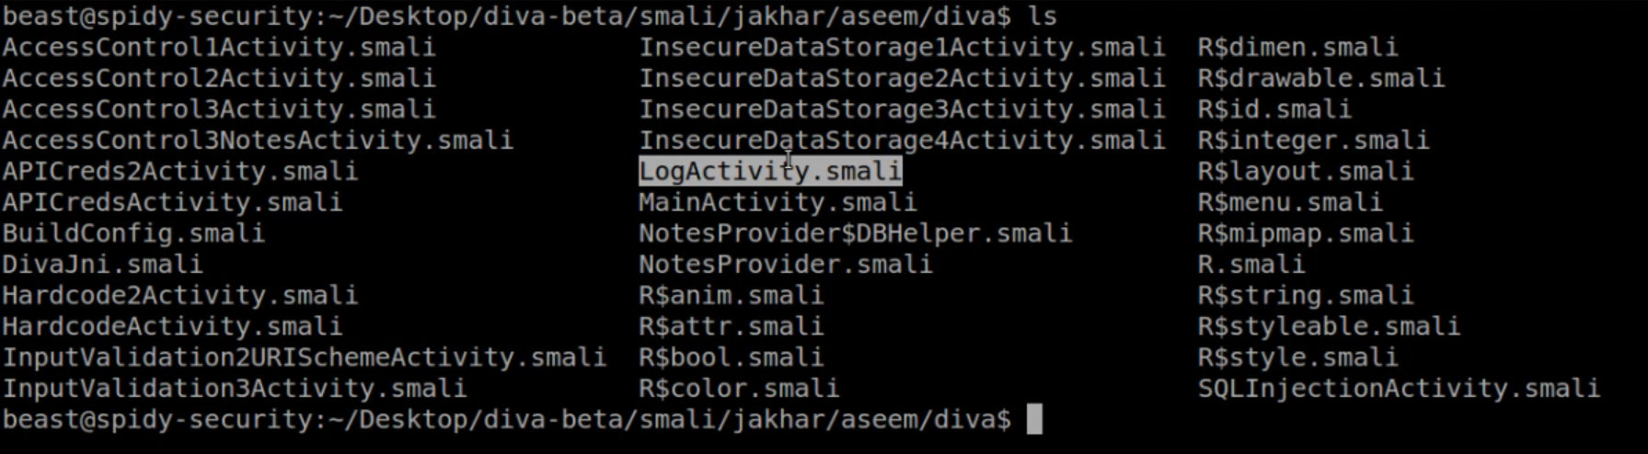

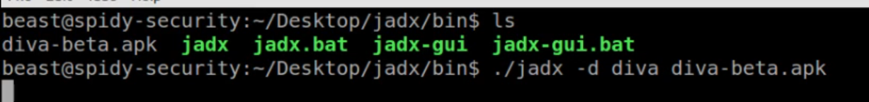

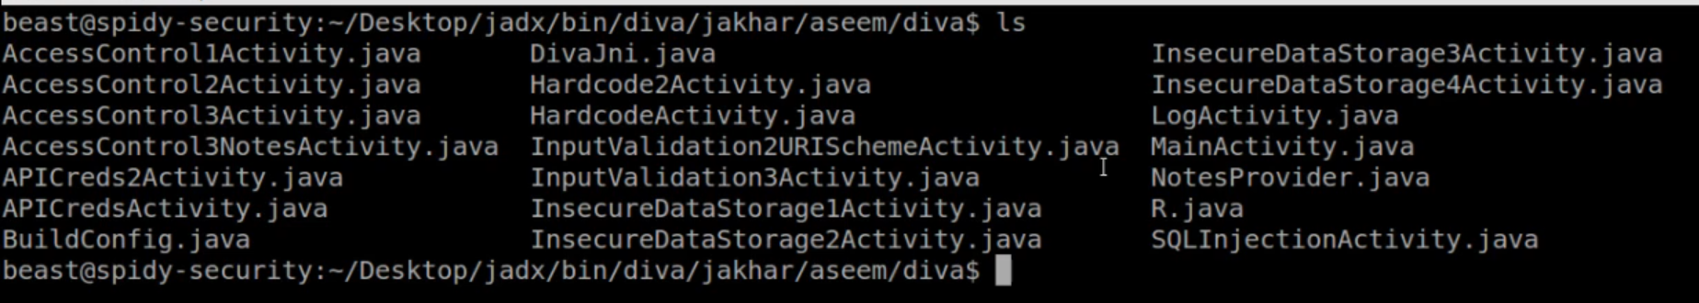

11 Application signing and Building

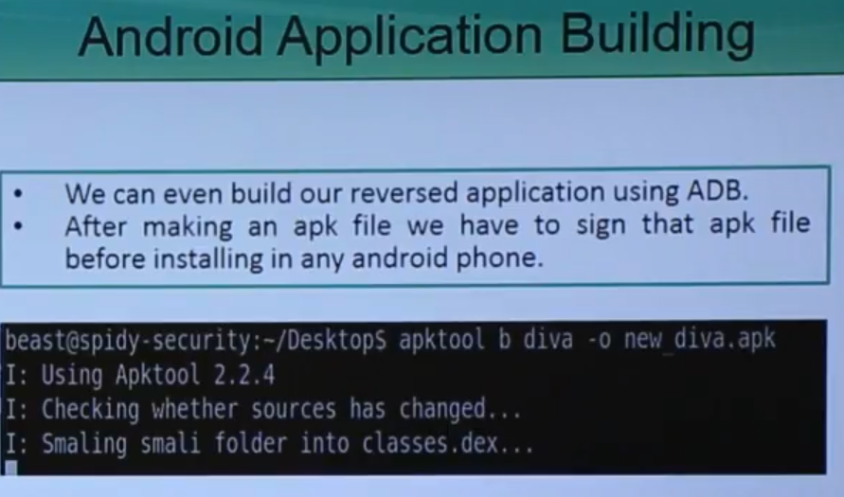

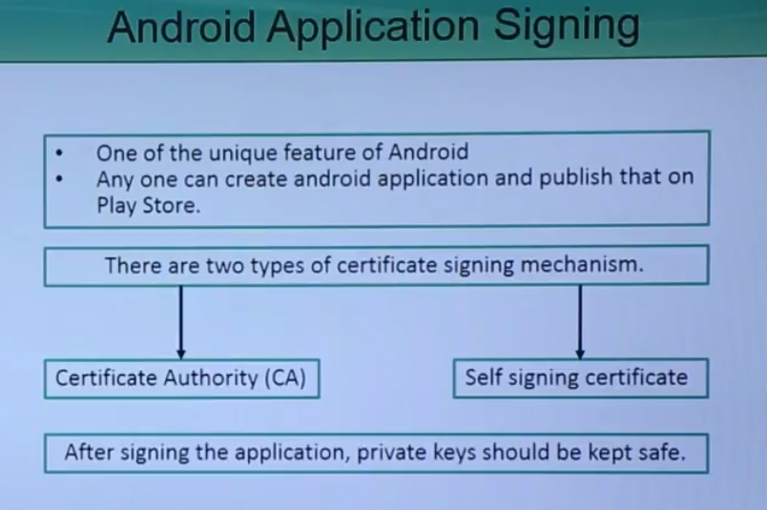

12 Analyzing Dex Files

